DIABETES RISK ANALYSIS
Project Report based on the supplied presentation and underlying Jupyter Notebook
This report documents the project as presented in the supplied PPT. It covers the dataset, data-quality checks, preprocessing, exploratory analysis, visualizations, code, workflow, findings, and the proposed next step for predictive modeling.

Introduction
Diabetes Risk Analysis is an exploratory data analysis and data-preparation project using Python. The project works with a diabetes dataset containing patient-related variables and an Outcome target. The presentation describes a workflow of loading data, inspecting its quality, cleaning selected values, exploring the target, visualizing feature relationships, and interpreting the results.

Project Objectives
- Load and inspect the diabetes dataset.
- Check missing values and duplicate records.
- Identify medically implausible zero values in selected physiological variables.
- Prepare the data by replacing invalid zeros and imputing median values.
- Study the distribution of the Outcome target.
- Analyze relationships among important numerical features using plots and correlations.
- Prepare the project for a later machine-learning prediction stage.

Dataset Description
Variable | Description
Pregnancies | Number of pregnancies
Glucose | Glucose level
BloodPressure | Blood pressure
SkinThickness | Skin thickness
Insulin | Insulin level
BMI | Body mass index
DiabetesPedigreeFunction | Diabetes family-history score
Age | Age of patient
Outcome | 0 = No Diabetes, 1 = Diabetes
The project contains 768 patient records and 9 columns. The Outcome variable is used as the classification target, with 0 representing no diabetes and 1 representing diabetes.

Data Quality and Preprocessing
- The initial missing-value check reported 0 missing values across the 9 columns.
- The duplicate-row check reported 0 duplicate records.
- Zeros in Glucose, BloodPressure, SkinThickness, Insulin and BMI were treated as invalid values foranalysis.
- These zeros were replaced with NaN.
- The resulting missing values were filled using the median of each respective column.
- After the cleaning process, the presentation reports 0 missing values.

Preprocessing code
zero_columns = [ "Glucose", "BloodPressure",
"SkinThickness", "Insulin", "BMI" ]
df[zero_columns] = df[zero_columns].replace(0, np.nan)
for column in zero_columns:
df[column] = df[column].fillna(df[column].median())

Target Variable Distribution
The target distribution contains 500 patients with Outcome = 0 and 268 patients with Outcome = 1. This corresponds to approximately 65.1% non-diabetic and 34.9% diabetic records. The distribution is therefore not perfectly balanced, which should be considered in a future predictive-modeling stage.

Exploratory Data Analysis
The project uses correlation analysis and feature-level visualizations to understand the dataset. A correlation heatmap is generated with Seaborn, while histograms with KDE curves compare feature distributions by Outcome. The presentation applies this analysis to Glucose, BMI, Age and BloodPressure.
Correlation code: sns.heatmap(df.corr(), annot=True, fmt=".2f", cmap="coolwarm")

Project Visualizations

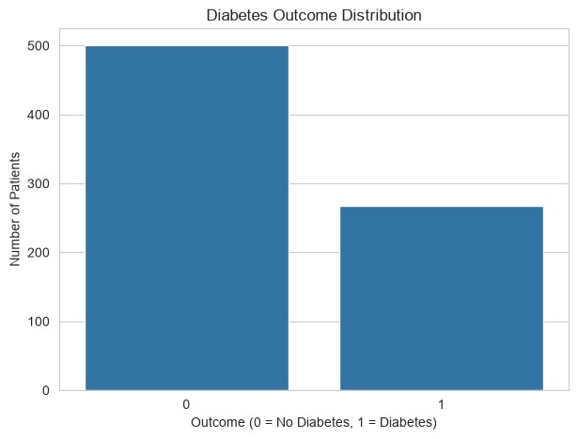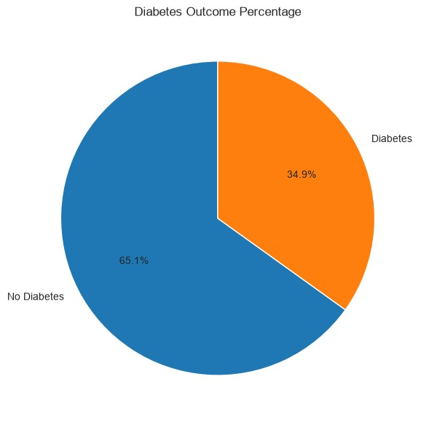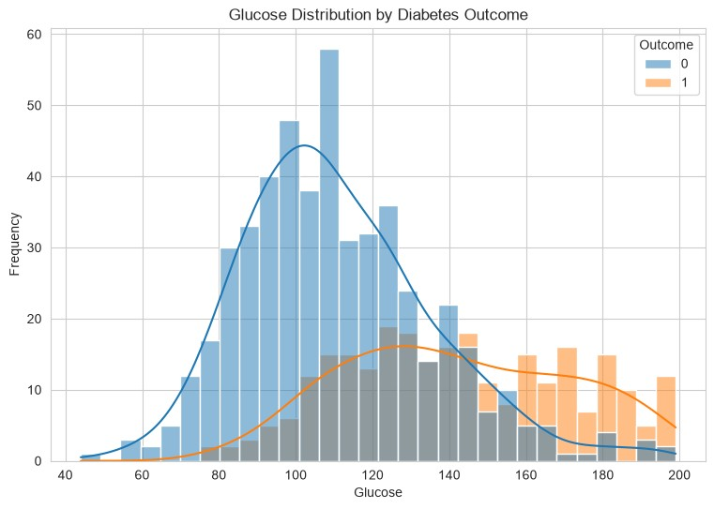

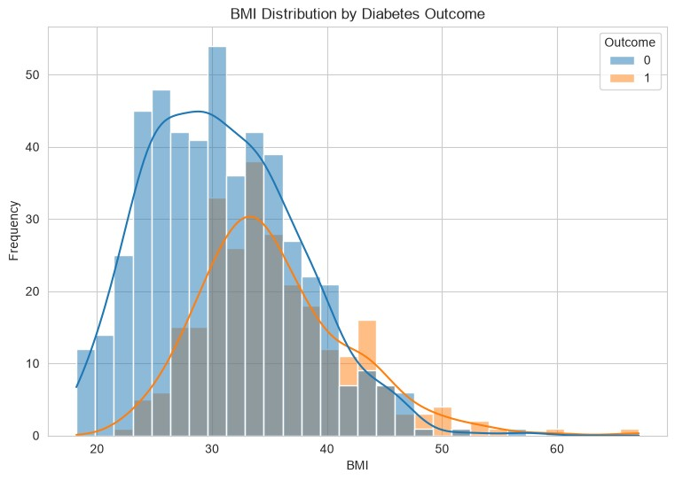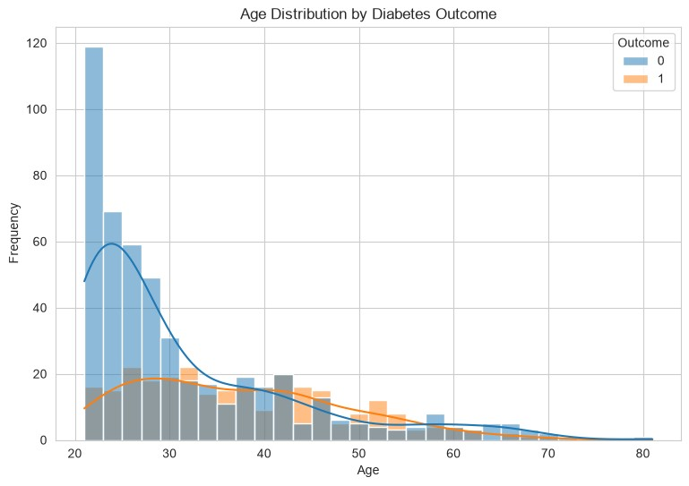

Feature Distribution Analysis
Histograms are used to compare the distributions of selected variables for Outcome 0 and Outcome 1. The code uses Seaborn's histplot with the Outcome column as the hue and KDE curves to provide a smoothed view of each distribution. Similar analysis is performed for Glucose, BMI, Age and BloodPressure.
plt.figure(figsize=(9, 6)) sns.histplot( data=df, x="Glucose", hue="Outcome", kde=True, bins=30 ) plt.title("Glucose Distribution by Diabetes Outcome") plt.xlabel("Glucose") plt.ylabel("Frequency") plt.show()

Box-Plot Analysis
Box plots are used to compare feature values against the Outcome target. The supplied project examines Glucose, BMI and Age. These plots help compare central tendency and spread between the two outcome groups and support exploratory analysis before predictive modeling.
sns.boxplot(data=df, x="Outcome", y="Glucose") sns.boxplot(data=df, x="Outcome", y="BMI") sns.boxplot(data=df, x="Outcome", y="Age")

Technologies and Libraries
- Python for programming and analysis.
- Pandas for data loading and manipulation.
- NumPy for numerical operations.
- Matplotlib and Seaborn for visualization.
- Scikit-learn for machine-learning preparation and model imports.
- Joblib is imported for model-related persistence.

Machine-Learning Readiness
The presentation shows imports for train_test_split, StandardScaler, LogisticRegression,
DecisionTreeClassifier, RandomForestClassifier, KNeighborsClassifier and SVC. It also imports metrics including accuracy, precision, recall, F1-score, confusion matrix, classification report, ROC curve and ROC-AUC. However, the supplied presentation explicitly states that the provided code ends after exploratory plots. Therefore, no model-training, accuracy, or other performance result is claimed in this report.

Project Workflow
- Load Data
- Inspect
- Clean
- Explore
- Visualize
- Interpret

Key Findings
- The dataset has 768 records, 8 input features and one Outcome target.
- 500 records are labeled Outcome 0 and 268 are labeled Outcome 1.
- No missing values or duplicates were found in the initial checks.
- Selected zero values were treated as invalid and replaced through median imputation.
- The project establishes an exploratory-analysis foundation for diabetes-risk prediction.

Conclusion
The Diabetes Risk Analysis project successfully establishes a structured exploratory-data-analysis and preprocessing workflow. It verifies the dataset quality, handles selected invalid values, examines the target distribution, and uses multiple visual techniques to study important features. The presentation also prepares the project for machine-learning development by importing classification algorithms and evaluation metrics. The next logical stage, as stated in the presentation, is to train and evaluate the imported models using a train/test split and suitable performance metrics.

Future Scope
- Split the cleaned dataset into training and testing sets.
- Scale features where appropriate.
- Train and compare the imported classification algorithms.
- Evaluate models using accuracy, precision, recall, F1-score and ROC-AUC.
- Use confusion matrices and ROC curves to compare model performance.
- Select and save the best-performing model for future diabetes-risk prediction.

